IndoorTemperature Service IDD

**Abstract**

This document defines the REST-JSON-TLS-TOKEN interface of the IndoorTemperature service.

1. IndoorTemperature Service Overview

This document describes the IndoorTemperature service, which is provided by a proof of concept Provider Application System of G4.0 with a REST interface.

1. Interfaces

Table 1 Function description

|  |  |  |  |  |
| --- | --- | --- | --- | --- |
| **Function** | **Path** | **Method** | **Input** | **Output** |
| getTemperature | /temperature | HTTP GET | ArrowheadToken | TemperatureReadout |

This Service only provides one interface, which is to serve the current temperature value. This information is provided in JSON, over HTTP(S).

When this Service is produced/offered over HTTPS, the metadata related to the security level has to be published in the Service Registry: **“security” = “token”. This is a mandatory Service metadata that must be associated when a System provides this.**

1. Information Model

The temperature is provided in SenML format [1]. The communication happens over HTTPS and the ArrowheadToken is implemented in the Service Provider resource when this Service is offered.

The HTTPS GET is submitted generally to the following schema:

https://<providerAddress>:<port>/<serviceURI>/temperature&token=<token>&signature=<signature***>***

Where the <signature> and <token> fields are filled out with the ArrowheadToken that is received in the Orchestration response – or from the TokenGeneration service response (when consumed directly).

These fields cannot contain the URL escape characters. Therefore, if the token or signature contain those, they shall be replaced. For example, spaces (ASCII, hexa 20) are not allowed in the signature, they shall be replaced with ‘%2b’ in the path parameter.

An example response in JSON is presented in Fig. 1.

{

"bn": "InsecureTemperatureSensor",

"bt": 1506943344134,

"bu": "celsius",

"e": [

{

"n": "IndoorTemperature",

"t": 1506943344134,

"v": 21

}

],

"ver": 1

}

**Figure 1. Example response, where the temperature is 21C.**

Where the fields are according to the standard.

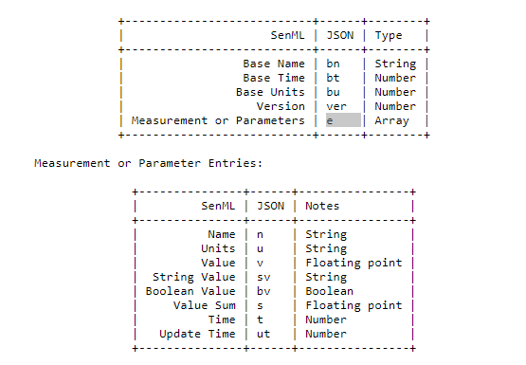

1. References

[1] https://tools.ietf.org/html/draft-jennings-senml-07#page-7

1. Revision history

# Amendments

|  |  |  |  |  |
| --- | --- | --- | --- | --- |
| No. | Date | Version | Subject of Amendments | Author |
| 1 | 2017-10-02 | 1.0 | Initial | Csaba Hegedűs |
| 2 | 2018-05-23 | G4.0 | Updated to G4.0 | Zoltán Umlauf |

# Quality Assurance

|  |  |  |  |
| --- | --- | --- | --- |
| No. | Date | Version | Approved by |
| 1 |  |  |  |
| 2 |  |  |  |